Dear colleagues, Dear friends,
here you can find the final instructions for the beginning of RIM (Radon Intercomparison Measuremets, 20-21 September 2010).
Groups (participants): Bossew, Ford, Roaldset, Wang, Ek &, Strauss &, Roca & will meet in front of the hotel DAP (workshop venue) at 7,45-8,00 on Monday 20th and will go with organizer´s cars to the area BUK. I (Matej Neznal) will be there as well and organize that
transport.
Groups (participants): Cosma &, Quindos &, Preusse &, Klingel &, Hovhannisyan &, Vaupotic &, Kies &, Roca &, Otahal, Fronka &, Matolin & can go directly with their own cars to the area BUK. Groups going from Prague can meet us in the morning in front of the hotel DAP as well, but I think the simpliest way is to go directly to the area Buk. Groups going from the Hotel u Milina near the reference areas will be directed by Martin Neznal (who will visit you at the hotel on Sunday evening/Monday morning).
At the beginning of RIM, on Monday at about 9,15-9,30, all we will meet at the reference area BUK for the registration and official start-up. (The registration announced at the web on Sunday evening is cancelled). I hope everything is clear, please if you have any question, do not hesitate to contact me.

Mobile phones:
Matej Neznal +420 602 293 722
Martin Neznal +420 602 285 621

RIM 2010
Instructions for Comparison measurement of radon in soil gas at radon reference sites in the Czech Republic

1. General information – purpose of measurement
Radon comparison measurements at radon reference sites serve for verification of field radon measurements performed by single organizations. Radon comparison measurement tests the calibration of the instrument, the technique of soil gas sampling, soil gas transfer into the detection chamber, radon-measuring procedure, stability of field measurements, elimination of thoron and data processing. Tests are based on the comparison of reported radon (²²²Rn) activity concentration in soil gas with other participants of comparison measurement and with the database of three reference sites.

2. Term of radon intercomparison measurements RIM 2010
Radon intercomparison measurement at reference sites RIM 2010 will be held on 20 and 21 September 2010

3. Place of radon intercomparison measurements RIM 2010
Radon intercomparison measurements RIM 2010 will be held at radon reference sites in the Czech Republic. Faculty of Science of the Charles University in Prague is the administrator of radon reference sites.

Three radon reference sites are located 60 km SW of Prague (Praha) near the city Milín (Fig. 1) in the Czech Republic. Three natural radon reference sites Cetyne, Bohostice and Buk, have been established in 2000, they are located on meadows, and are accessible for cars. Their mutual total distance is 12 km. Each reference site implies 15 stabilized stations in a grid of 5x5 m, which are marked by numbers. Separate reference sites differ in radon activity concentration in soil gas, the radon distribution within the reference site is relatively homogeneous, thickness and permeability of soils enable soil gas sampling at the reference depth of 0.8 m. Geological setting at radon reference sites was investigated by geophysical methods. Temporal radon variations were recorded in 2000 – 2010. There is no electrical power supply at radon reference sites, however a power supply generator can be provided on the request (See Questionnaire).

Table 1 Characteristic of radon reference sites in the Czech Republic

Reference  site | c_{A} ²²²Rn (kBq/m³) | Permeab. of soil | Rock | Soil | U (ppm) | Terrain | Access for cars
Cetyne | 32 | L,(M),H | orthogneiss | SL | 2.0 | meadow | +
Bohostice | 47 | (L),(M),H | orthogneiss | LS,CS | 2.3 | meadow | +
Buk | 146 | H | granodiorite | LS | 3.6 | meadow | +
L – Low, M – Medium, H – High
SL – sandy loam, LS – loamy sand, CS – clay sand,

4. Radon intercomparison measurement RIM 2010
Radon comparison measurement at reference sites is organized for a group of participants. Each organization measures radon at 15 stabilized stations of each reference site by its own technique (however a lower number of stations can be measured within the available time as well). Soil air is sampled from the depth of 0.8 m near to each stabilized station. Measurement at three radon reference sites RIM 2010 is planned for 2 days. Each organization reports data on the activity concentration of radon in soil gas (kBq/m³) at single stations of reference sites filled in a provided form. The form with results should be handed over to the Administrator in a short term (during the workshop) or if necessary mailed electronically by 30 September 2010 to the e-mail address: matolin@natur.cuni.cz.

5. Tests of radon comparison measurement
Tests are based on comparison of radon data reported by participating organization with radon data of the group, and with radon data of a databank of the respective reference site. The computer programme TestMOAR evaluates the reported radon data. Three tests based on statistics were developed and programmed by the Institute of Applied Mathematics and Computer Technique, Faculty of Science, Charles University in Prague. Test No. 1 calculates differences between radon activity concentration at single stations (N = 15) of a reference site, reported by the organization, and a median of radon data reported by the group, which measured radon at identical stations in the same day of measurement. Test No. 2 determines the regression y = a + bx between radon activity concentration at all measured stations of the three reference sites (N = 3x15 = 45 stations) reported by tested organization (y), and median (x) of radon data for relevant stations reported by the administrator and all other organizations measuring the same day. Test No. 3 is the comparison of mean radon concentration in soil gas reported by the organization for a single reference site with radon database of the reference site. At present (2010), the database of each radon reference site comprises 171 data sets of successful measurements of organizations during the period 2000 – 2010. The testing criterion, which has the ideal value equal to one, accepts deviations of standardized radon data in the range 0.7 - 1.3 (30 % relative deviation). Test is performed for every reference site separately. The use of standardized radon data of the organization and the database eliminates temporal variation of radon activity concentration in soil gas in the Test No.3. Computer programme TestMOAR accepts reduced number of radon data observed at a reference site. Results of tests will be anonymous; each organization will be denoted by a code.

6. Results of radon intercomparison measurement RIM 2010
Each participant of RIM 2010 will receive his assessment protocol introducing numerical results of Tests No. 1, 2 and 3 and a graph of radon data dispersion of the group (in codes) at 3 reference sites. Assessment protocols and results of intercomparison measurement RIM 2010 will be available after all participants will hand over their data on measured radon concentration at reference sites.

7. Transport Prague – reference sites
Organizers of the workshop on request will provide transport Prague - reference sites (See Questionnaire).

8. Preliminary time schedule
Monday, 20 September 2010
8.00 Departure from Prague
9.30 - 12.30 Measurement at reference sites Cetyne and Bohostice
13.30 - 16.00 Measurement at reference sites Cetyne, Bohostice and Buk
16.00 - 17.00 Discussion at reference site Buk, closing of the first day, departure to Prague (or to the local hotel)
Tuesday, 21 September 2010
8.00 Departure from Prague
9.30 - 12.00 Measurement at reference site Buk
12.00 - 13.00 Discussion at reference site Buk, closing of the RIM, departure to Prague (or to the local hotel)
Note: Refreshment (tea, coffee, beer, sausages) will be available at reference site Buk during the whole intercomparison measurement.

Accommodation. Suitable accommodation, just in the area of radon reference sites, is available in “Hotel u Milina” (www.hotelumilina.cz).

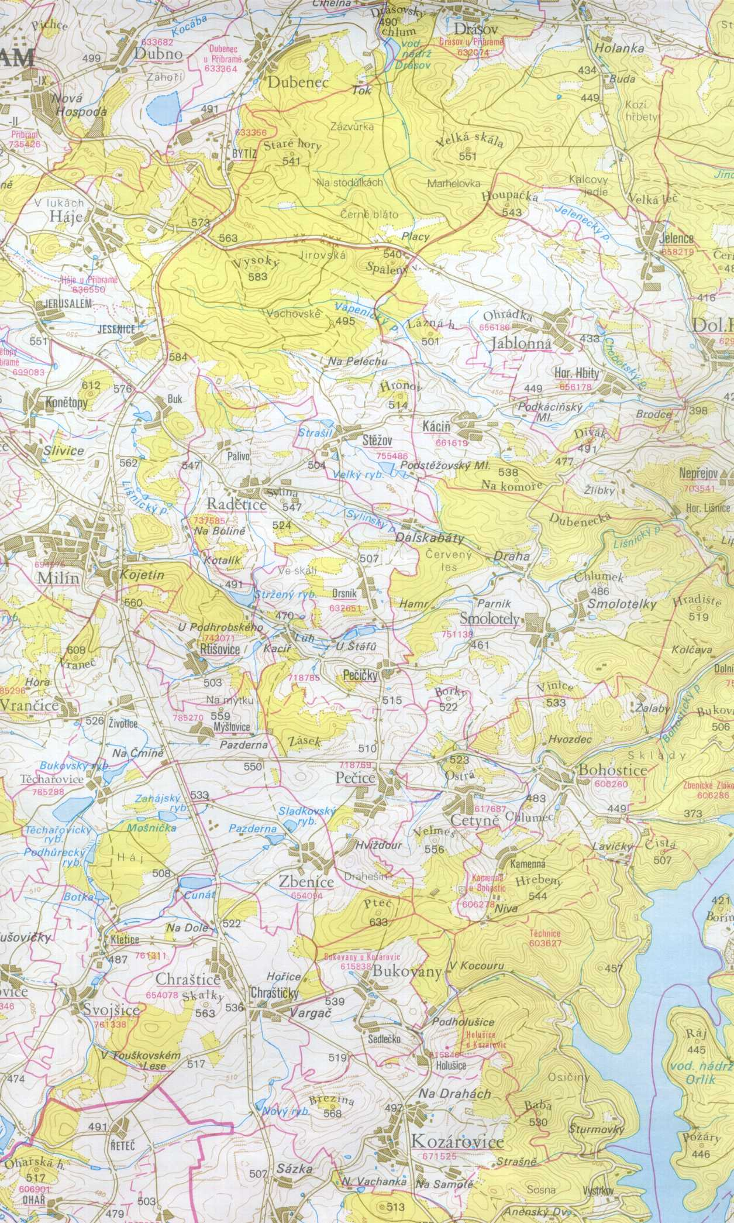
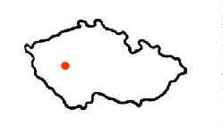
Hotel
U Milína
www.hotelumilina.cz

Praha

Location of radon reference sites in the Czech Republic
PROTOCOL

RIM 2010 - Radon comparison measurement at reference sites Czech Republic

Name of organization:
Address of organization:
E-mail:

Date of measurement:
Operator (name):

Sampling method
Type of sampling probe (“Neznal” probe, packer probe, or other):
Method of soil air sampling (pump, janette, or other):

Measuring method (ionization chambers, Lucas cells, or other):

Type of instrument:
Serial No.:
Date and place of calibration:
Pause between the soil air sampling and measurement (minutes):

Table Radon (²²²Rn) activity concentration determined at radon reference sites

 | Cetyně |  | Bohostice |  | Buk
 | Depth | c_{A} | Depth | c_{A} | Depth | c_{A}
Station No. | m | kBq/m³ | m | kBq/m³ | m | kBq/m³
1
2
3
4
5
6
7
8
9
10
11
12
13
14
15
Depth = depth of soil gas sampling

