RIM 2012
Instructions for Comparison measurement of radon in soil gas at radon reference sites in the Czech Republic

1. General information – purpose of measurement
Radon comparison measurements at radon reference sites serve for verification of field radon measurements performed by single organizations. Radon comparison measurement tests the calibration of the instrument, the technique of soil gas sampling, soil gas transfer into the detection chamber, radon-measuring procedure, stability of field measurements, elimination of thoron and data processing. Tests are based on the comparison of reported radon (²²²Rn) activity concentration in soil gas with other participants of comparison measurement and with the database of two reference sites.

2. Term of radon intercomparison measurements RIM 2012
Radon intercomparison measurement at reference sites RIM 2012 will be held on 17 September 2012.

3. Place of radon intercomparison measurements RIM 2012
Radon intercomparison measurements RIM 2012 will be held at two radon reference sites in the Czech Republic. Faculty of Science of the Charles University in Prague is the administrator of radon reference sites.

The radon reference sites are located 60 km SW of Prague (Praha) near the city Milín (Fig. 1) in the Czech Republic. The natural radon reference sites Bohostice and Buk, have been established in 2000, they are located on meadows, and are accessible for cars. Each reference site implies 10 stabilized stations, which are marked by numbers. Separate reference sites differ in radon activity concentration in soil gas, the radon distribution within the reference site is relatively homogeneous, thickness and permeability of soils enable soil gas sampling at the reference depth of 0.8 m. Geological setting at radon reference sites was investigated by geophysical methods. Temporal radon variations were recorded in 2000 – 2012. There is no electrical power supply at radon reference sites, however a power supply generator can be provided on the request (See Questionnaire).

Table 1 Characteristic of radon reference sites

Reference  site | c_{A} ²²²Rn (kBq/m³) | Permeab. of soil | Rock | Soil | U (ppm) | Terrain | Access for cars
Bohostice | 47 | (L),(M),H | orthogneiss | LS,CS | 2.3 | meadow | +
Buk | 146 | H | granodiorite | LS | 3.6 | meadow | +
L – Low, M – Medium, H – High
LS – loamy sand, CS – clay sand,

4. Radon intercomparison measurement RIM 2012
Radon comparison measurement at reference sites is organized for a group of participants. Each organization measures radon at 10 stabilized stations of each reference site by its own technique. Soil air is sampled from the depth of 0.8 m near to each stabilized station. Measurement at two radon reference sites RIM 2012 is planned for 1 day. Each organization reports data on the activity concentration of radon in soil gas (kBq/m³) at single stations of reference sites filled in a provided form. The form with results should be handed over to the Administrator in a short term (during the workshop) or if necessary mailed electronically by 10 October 2012 to the e-mail address: matolin@natur.cuni.cz.

5. Tests of radon comparison measurement
Tests are based on comparison of radon data reported by participating organization with radon data of the group, and with radon data of a database of the respective reference site. The computer programme TestMOAR evaluates the reported radon data. Three tests based on statistics were developed and programmed by the Institute of Applied Mathematics and Computer Technique, Faculty of Science, Charles University in Prague. Test No. 1 calculates differences between radon activity concentration at single stations (N = 10) of a reference site, reported by the organization, and a median of radon data reported by the group, which measured radon at identical stations in the same day of measurement. Test No. 2 determines the regression y = a + bx between radon activity concentration at all measured stations of the two reference sites (N = 2x10 = 20 stations) reported by tested organization (y), and median (x) of radon data for relevant stations reported by the administrator and all other organizations measuring the same day. Test No. 3 is the comparison of mean radon concentration in soil gas reported by the organization for a single reference site with radon database of the reference site. At present (2012), the database of each radon reference site comprises 198 data sets of successful measurements of organizations during the period 2000 – 2012. The testing criterion, which has the ideal value equal to one, accepts deviations of standardized radon data in the range 0.7 - 1.3 (30 % relative deviation). Test No. 3 is performed for every reference site separately. The use of standardized radon data of the organization and the database in the Test No.3 eliminates temporal variation of radon activity concentration in soil gas. Computer programme TestMOAR accepts reduced number of radon data observed at a reference site. Results of tests will be anonymous; each organization will be denoted by a code.

Optional measurement:

In addition, all participating organizations will be asked to collect soil gas samples from three permanently installed “Neznal” probes (RADON v.o.s.) located near the stations No. 1, 2 and 3 at the reference site Bohostice and to determine radon concentrations in the samples using their own method. At the same time, cross-checking will take place: RADON v.o.s will take samples from sampling probes of all participating organization at the same sampling points (near stations No. 1, 2 and 3 at the reference site Bohostice) using its own sampling system (syringe). Radon concentrations in the samples will be then measured using Lucas cells. The additive results should allow to get more information on primary calibration of different measurement devices and on the correctness of sampling systems. The above mentioned additive measurements will be optional.

6. Results of radon intercomparison measurement RIM 2012
Each participant of RIM 2012 will receive his assessment protocol introducing numerical results of Tests No. 1, 2 and 3 and a graph of radon data dispersion of the group (marked in codes) at 2 reference sites. Assessment protocols and results of intercomparison measurement RIM 2012 will be available after all participants will hand over their data on measured radon concentration at reference sites.

7. Transport Prague – reference sites
Organizers of the workshop on request will provide transport Prague - reference sites (See Questionnaire).

8. Preliminary time schedule
Monday, 17 September 2012
8.00 Departure from Prague
9.30 - 12.30 Measurement at reference site Bohostice
13.30 - 16.00 Measurement at reference site Buk
16.00 Departure to Prague

Note: Refreshment (tea, coffee, beer, sausages) will be available at reference site Bohostice during the whole intercomparison measurement.

Accommodation (If you prefer to start your journey to Czech Republic near the reference sites, not in Prague): Suitable accommodation, just in the area of radon reference sites, is available in “Hotel u Milina” (www.hotelumilina.cz).

Lunch on Monday, 17 September 2012, can be obtained in the nearby village Bohostice (2 km from the reference site Bohostice), or in the “Hotel u Milina”.

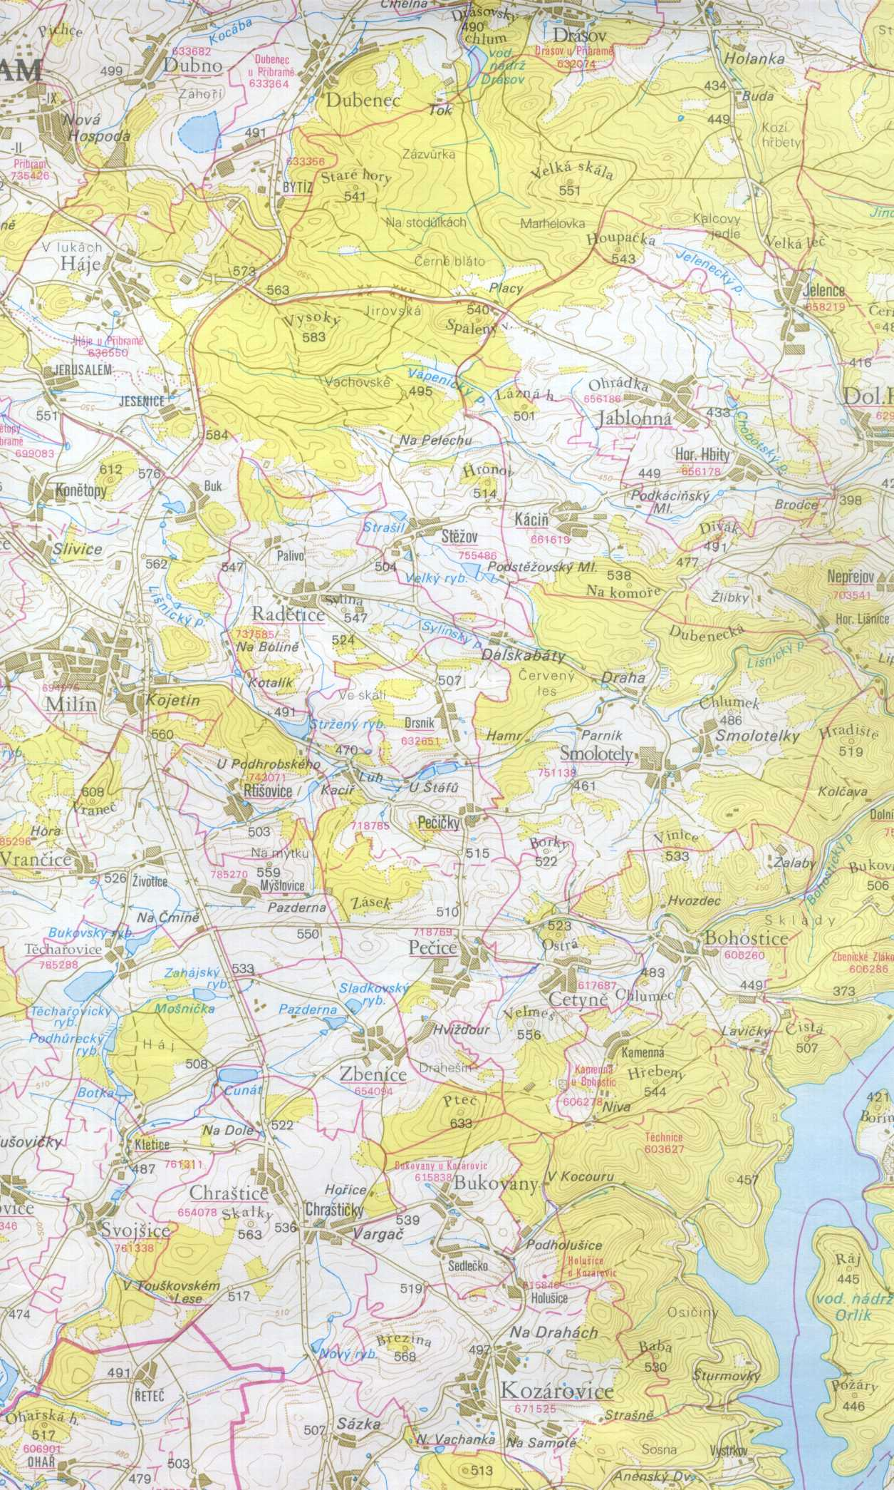
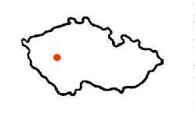
Praha

Hotel
U Milína
www.hotelumilina.cz

Location of radon reference sites Bohostice and Buk, Czech Republic

Location of radon reference sites Bohostice and Buk in the Czech Republic

PROTOCOL

RIM 2012 - Radon comparison measurement at reference sites Czech Republic

Name of organization:
Address of organization:
E-mail:

Date of measurement:
Operator (name):

Sampling method
Type of sampling probe (“Neznal” probe, packer probe, or other):
Method of soil air sampling (pump, janette, or other):

Measuring method (ionization chambers, Lucas cells, or other):

Type of instrument:
Serial No.:
Date and place of calibration:
Pause between the soil air sampling and measurement (minutes):

Table Radon (²²²Rn) activity concentration determined at radon reference sites

 | Bohostice |  | Buk
 | Depth | c_{A} | Depth | c_{A}
Station No. | m | kBq/m³ | m | kBq/m³
1
2
3
4
5
6
7
8
9
10
Additive measurements (sampling from “Neznal” probes - optional)
1
2
3
Depth = depth of soil gas sampling

